**NEMA 17 Connection with A4988**

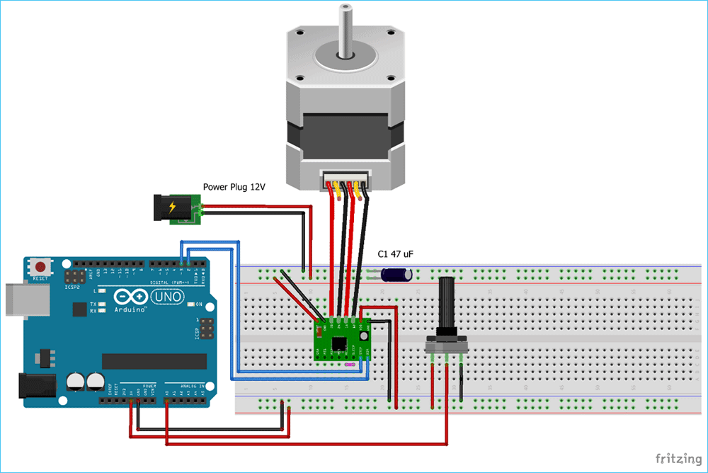

|  |  |
| --- | --- |
| **A4988** | **Connection** |
| VMOT | +ve of the Battery |
| GND | -ve of the Battery |
| VDD | 5V of Arduino |
| GND | GND of Arduino |
| STP | Pin 3 of Arduino |
| 1A, 1B, 2A, 2B | Stepper Motor. |

**ULN2003 Connections**

**BYJ48 Left**

|  |  |
| --- | --- |
| **ULN2003** | **Connections** |
| IN1 | Arduino Pin 4 |
| IN2 | Arduino Pin 5 |
| IN3 | Arduino Pin 6 |
| IN4 | Arduino Pin 7 |
| + | Power Supply Positive |
| **-** | Power Supply GND and Arduino GND. (One Common GND) |

**BYJ48 Right**

|  |  |
| --- | --- |
| **ULN2003** | **Connections** |
| IN1 | Arduino Pin 8 |
| IN2 | Arduino Pin 9 |
| IN3 | Arduino Pin 10 |
| IN4 | Arduino Pin 11 |
| + | Power Supply Positive |
| **-** | Power Supply GND and Arduino GND. (One Common GND) |

**TFMini Connections**

|  |  |
| --- | --- |
| **TFMini Lidar** | **Connections** |
| TX | Pin 12 of Arduino |
| RX | Pin 13 of Arduino |
| VCC | 5v of Arduino |
| GND | GND of Arduino |

**Push Button Connections**

